**SAP BW/BO Exercise**

**Exercise# : HANA Data Modeling Part 2 (Analytic View)**

**Student Name: Nupur Ray Student Id: nxr163130**

**Date: 09/28/2016 HANA Login Id: GBI_345**

**Note: You must use the following conventions to name objects/systems created in this exercise.**

**Replace S with the semester**

**A for Fall**

**B for Spring**

**C for Summer**

**Replace XX with the two character year (ex. 20 for 2020)**

**Replace YYY with your Student ID (ex. 147 if you were issued ID GBI_147)**

**Please use the screenshots ONLY as a reference. The instructions have to be followed AS-IS.**

Objective

In the previous exercise we created customer and product attribute view. In this exercise we will be combining these attribute views (dimension) with sales (fact) and form an analytic view (Info cube). Also, we will do some reporting on the view in HANA Studio.

1. Create an analytic view

You want to analyze the sales data by customer and product.

Therefore, you create a simple star schema that includes facts from your sales table. The customer attribute view and product attribute view will represent the dimensions in the star schema.

The star schema is shown in the figure below.

Sales data table

SALES_***YYY***

Customer attribute view

CUSTOMER_ATV_***YYY***

Product attribute view

PRODUCT_ATV_***YYY***

* 1. Create a new analytic view for the sales data in your package

Use following details to create the view:

**Package name**: SXX.GBI_YYY

**View name**: SALES_AV_**YYY**

**View description**: Sales **YYY**

**Tables:** SALES_**YYY**

**Views:** CUSTOMER_ATV_**YYY**PRODUCT_ATV_**YYY**

Steps:

1. Navigator View
2. Content

Package SXX.GBI_YYY → Right click → New → Analytic View

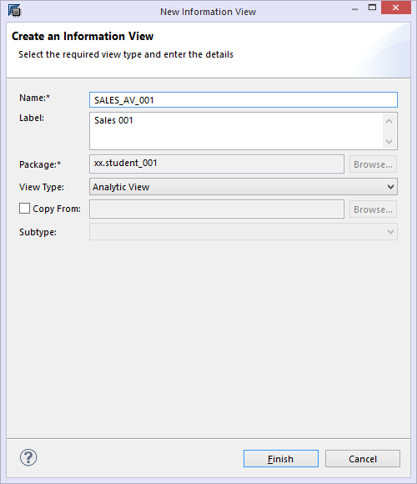

1. Add the Sales table to Data Foundation. Right click 🡪Add Objects

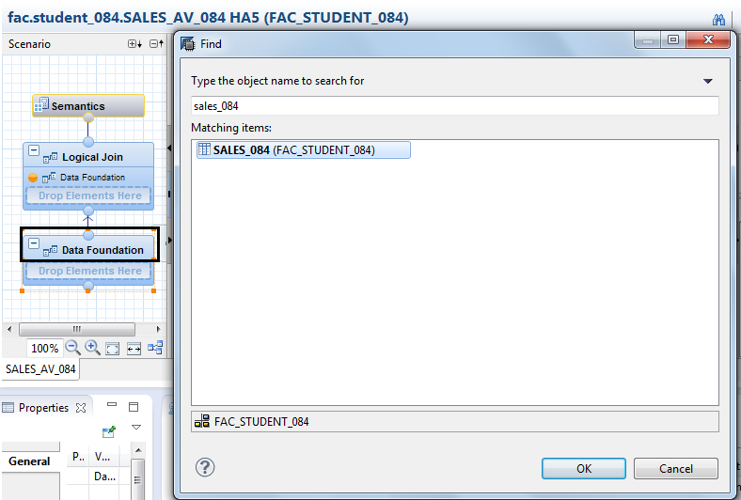

1. In order to separate the order date of SALES_XXX table, we would be using M_TIME_DIMENSION under the _SYS_BI folder (Catalog)

Add the M_TIME_DIMENSION table to Data Foundation. Right click 🡪Add Objects

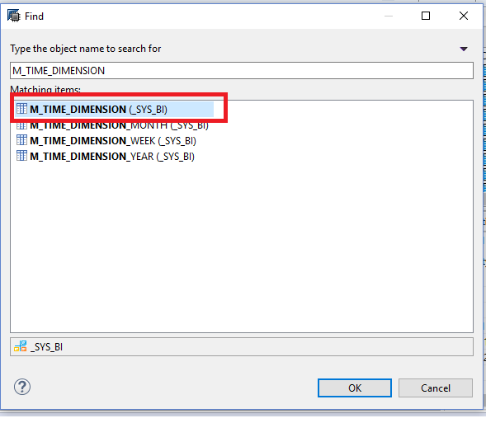

1. Add newly created views to Logical Foundation

Right click 🡪Add Objects

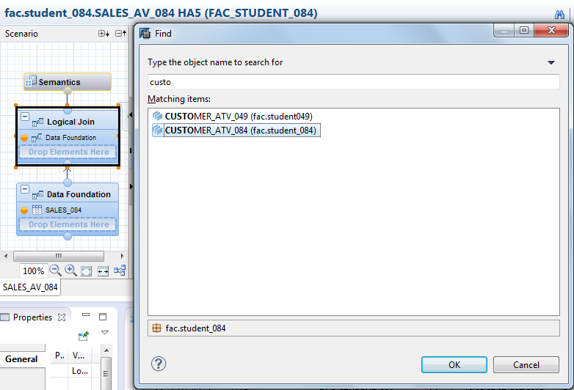

Press Ok.

Similarly, add Product view

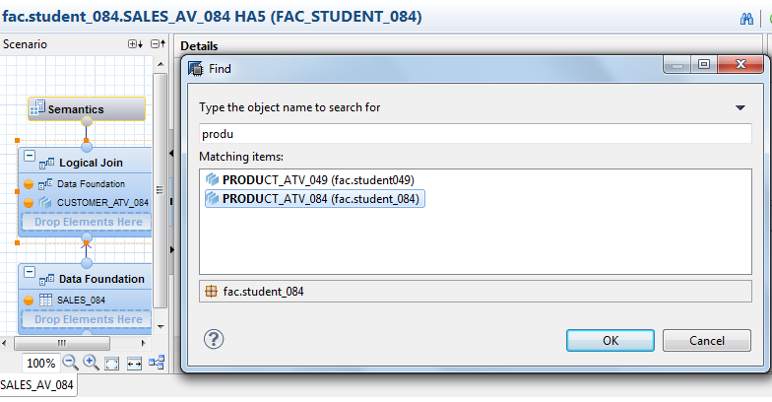

1. Click on Data Foundation. Join SALES_YYY and M_TIME_DIMENSION using referential join. Drag and drop ORDER_DATE TO DATE_SQL

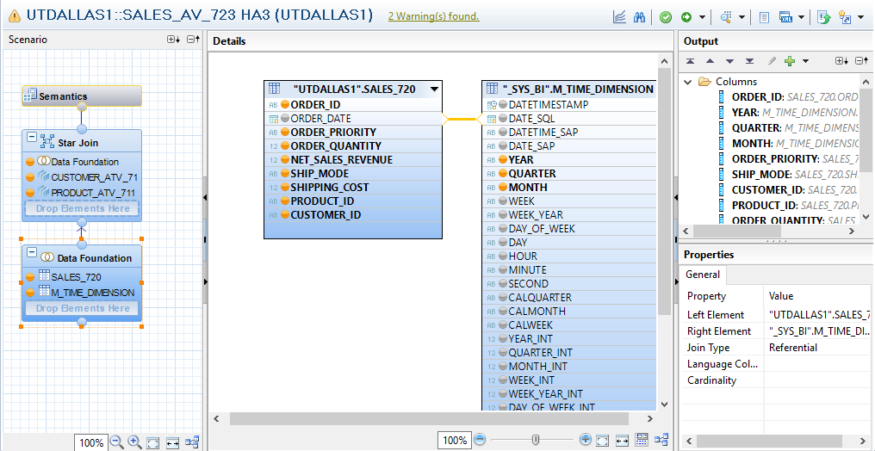

* 1. The sales data table represents the data foundation in your view. Following fields of the sales data table should be included in the output structure of the analytic view:

|  |  |  |
| --- | --- | --- |
| **Table** | **Field** | **Type** |
| SALES_**YYY** | ORDER_ID | attribute |
| M_TIME_DIMENSION | YEAR | attribute |
| M_TIME_DIMENSION | QUARTER | attribute |
| M_TIME_DIMENSION | MONTH | attribute |
| SALES_**YYY** | ORDER_PRIORITY | attribute |
| SALES_**YYY** | ORDER_QUANTITY | measure |
| SALES_**YYY** | NET_SALES_REVENUE | measure |
| SALES_**YYY** | SHIP_MODE | attribute |
| SALES_**YYY** | SHIPPING_COST | measure |
| SALES_**YYY** | PRODUCT_ID | attribute |
| SALES_**YYY** | CUSTOMER_ID | attribute |

Steps:

1. On the Data Foundation component, select the relevant fields of table SALES_*YYY* and choose Add to Output to add them to the output structure.

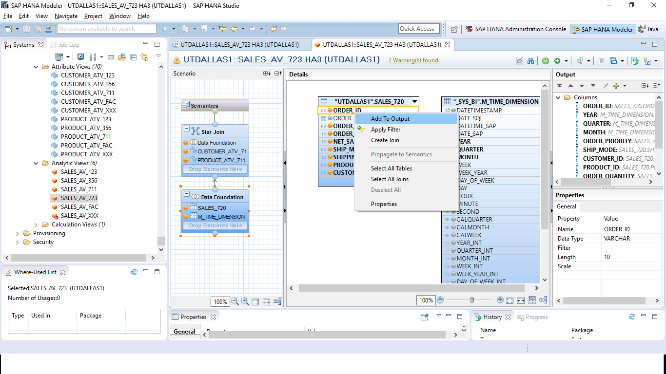

1. Select the *Semantics* component to change the type of the output fields.

Click on the Semantic

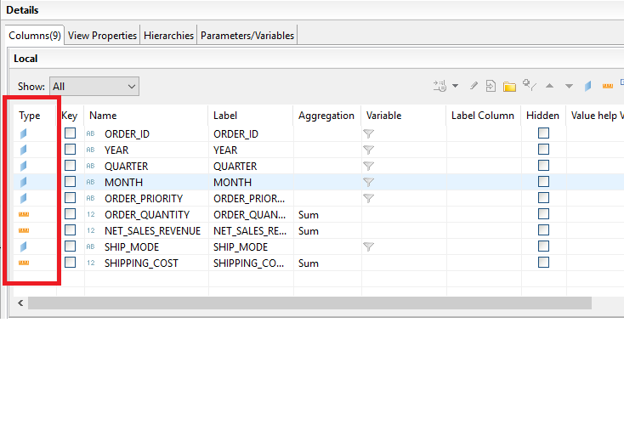

* 1. Join the sales table with the product and customer view, using a referential join

Switch to the Logical Join component.

Drag & drop field DATAFOUNDATION.CUSTOMER_ID_1 to field CUSTOMER_ATV_YYY.CUSTOMER_ID.

Drag & drop field DATAFOUNDATION.PRODUCT_ID_1 to field   
PRODUCT_ATV_YYY.PRODUCT_ID.

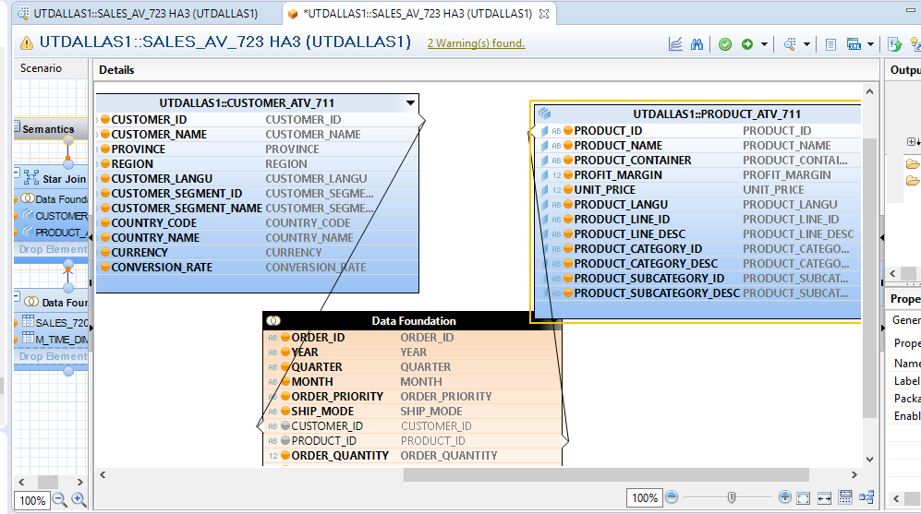

2.4 Question:

Paste the screenshot here:

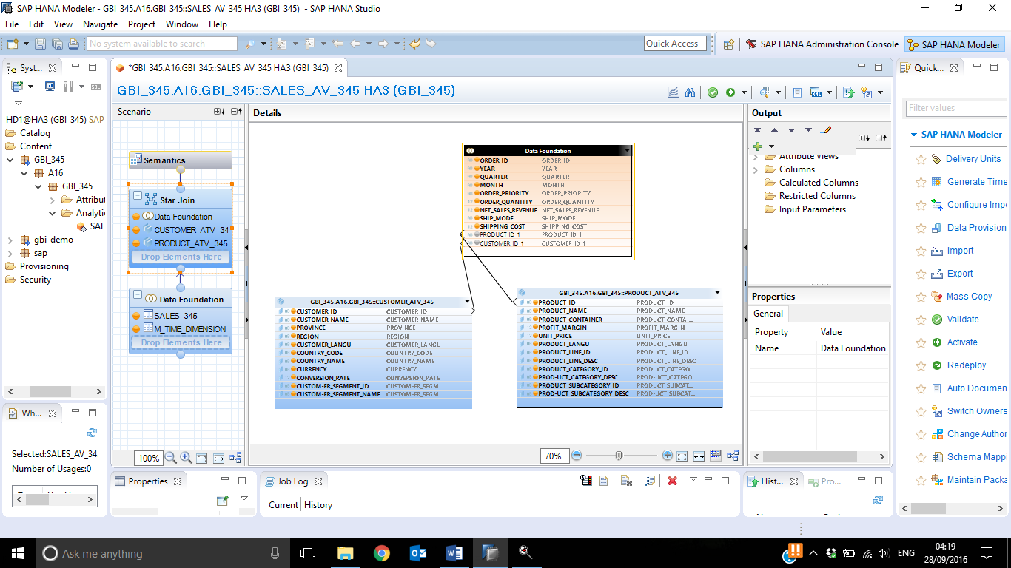

Add the discount price as calculated measure to the output structure of your view

In the output structure of the analytic view, select the folder Calculated Columns and choose New… from the context menu. Enter the details as indicated in the screenshots.

Use following details to create the calculated measure:

Name: DISCOUNT

Description: Discount

Formula: (UNIT_PRICE * ORDER_QUANTITY) – (NET_SALES_REVENUE – SHIPPING_COST)

Regarding the currency, enter following details:

Measure (Column) Semantic Type: Amount with Currency

Currency: Attribute *USD*.

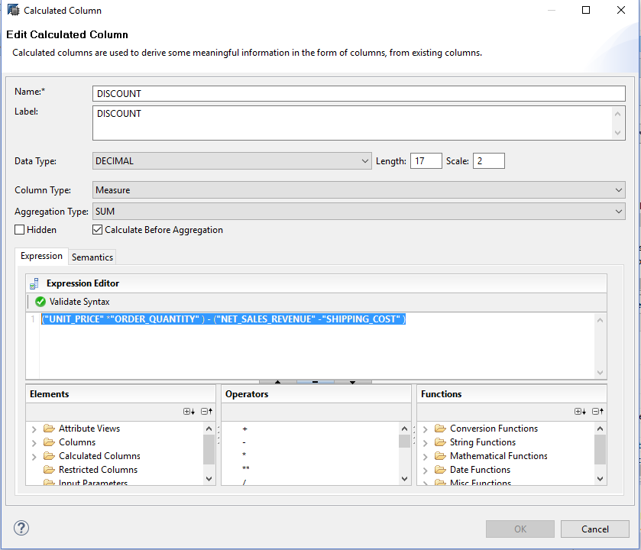

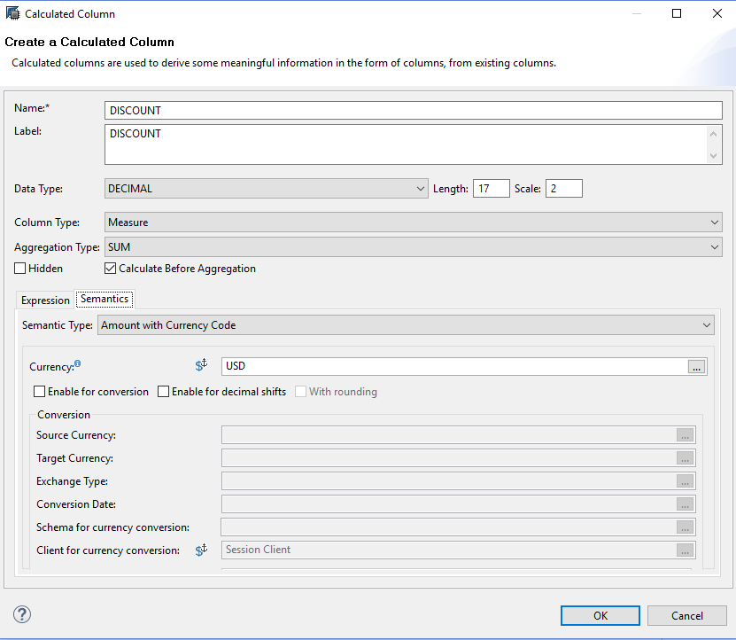

* 1. Add the profit as calculated measure to the output structure of your view

I n the output structure of the analytic view, select the folder Calculated Columns and choose New… from the context menu. Enter the details as indicated in the screenshots.

Use following details to create the calculated measure:

Name: PROFIT

Description: Profit

Formula: PROFIT_MARGIN * (NET_SALES_REVENUE – SHIPPING_COST)

Regarding the currency, enter following details:

Measure (Column) Semantic Type: Amount with Currency

Currency: Attribute *USD*.

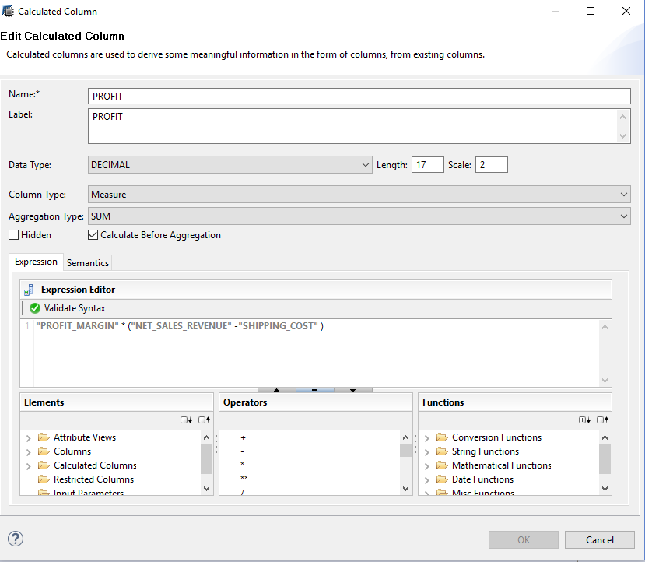

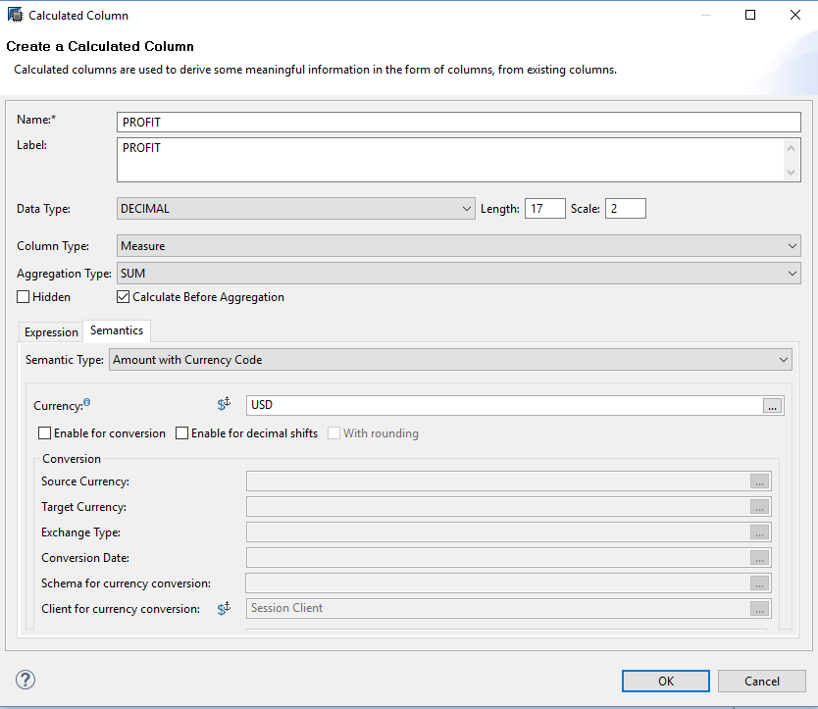

* 1. Save, validate and activate the view.

Press Save and Validate.

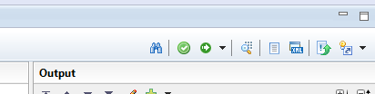

Check the Job Log. In case of an error, the job is highlighted in red.

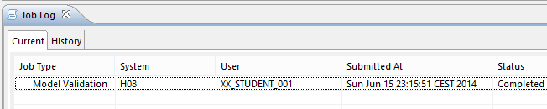

Press Save and Activate.

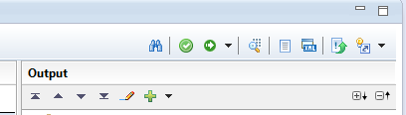

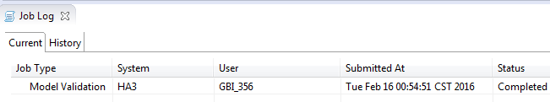

Check the Job Log. In case of an error, the job is highlighted in red.

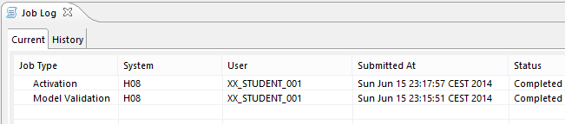

* 1. Paste the screenshot of the Output structure along with the newly created calculated columns.

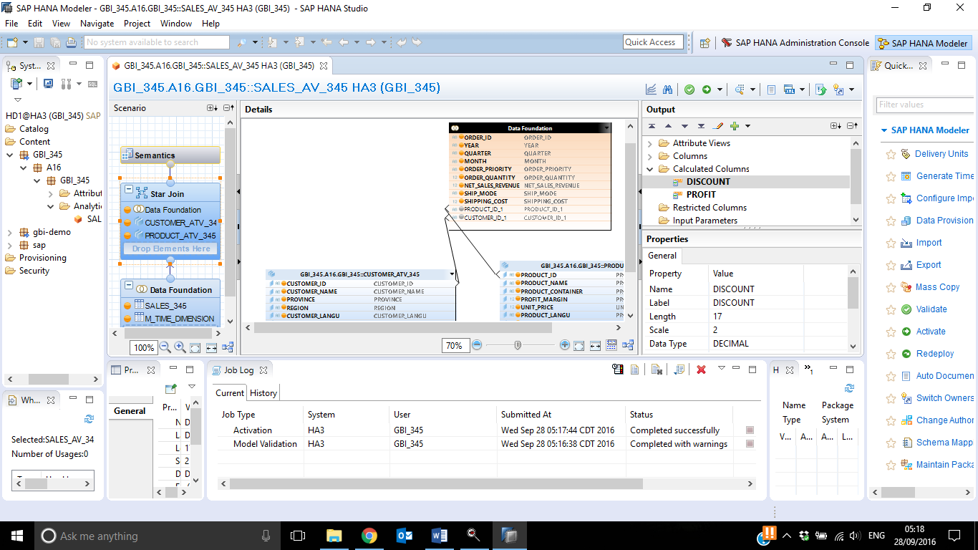

* 1. Open the data preview for your analytic view and check the data.

Content → SXX.GBI_YYY → Right click → Data Preview

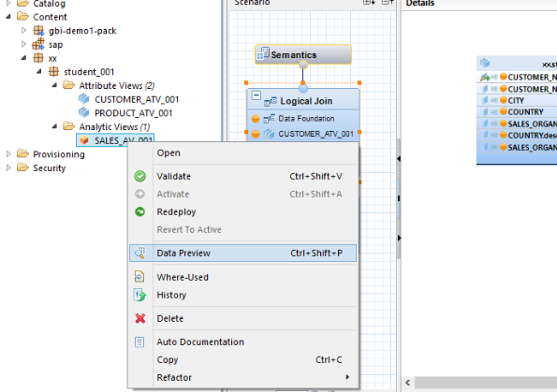

Question:

Paste the screenshot of the data preview: Raw Data

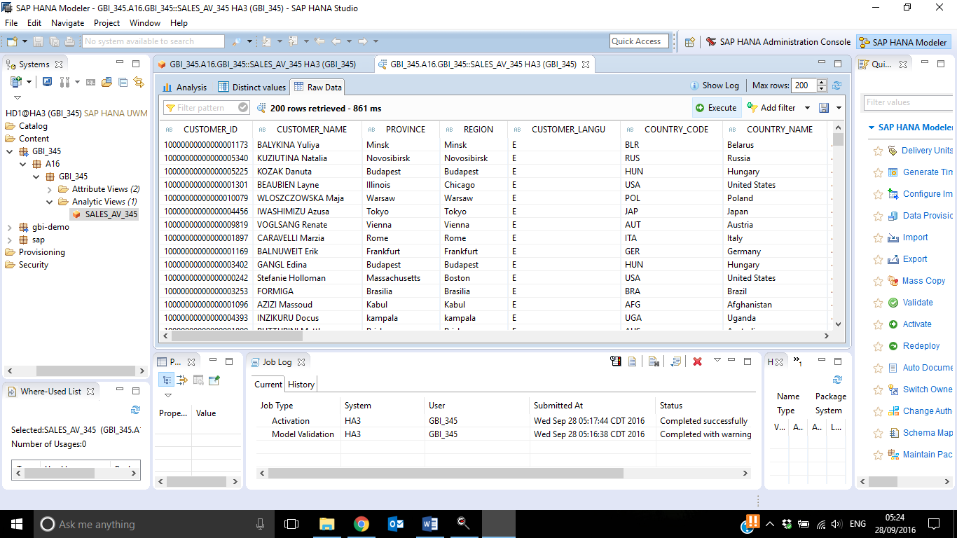

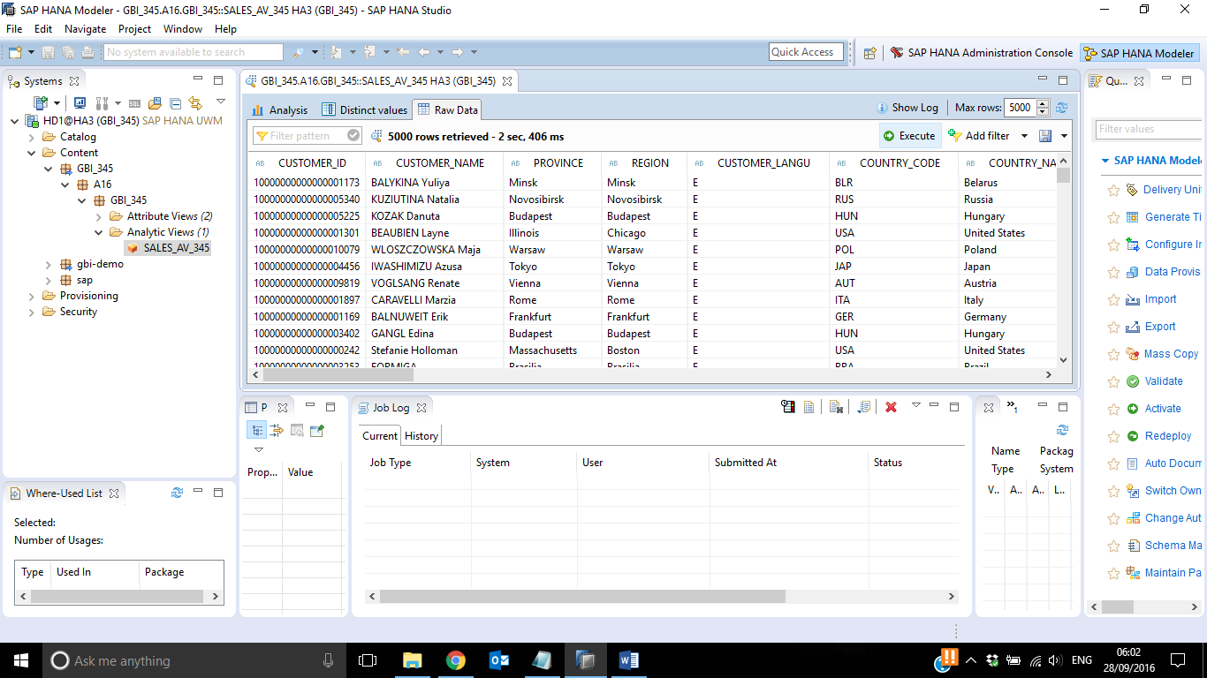

1. Let us do some basic reporting in HANA studio on this view.
2. Navigator View → Content → SXX.GBI_YYY → Analytic View → SALES_AV_YYY → Right click→ Open Data Preview.

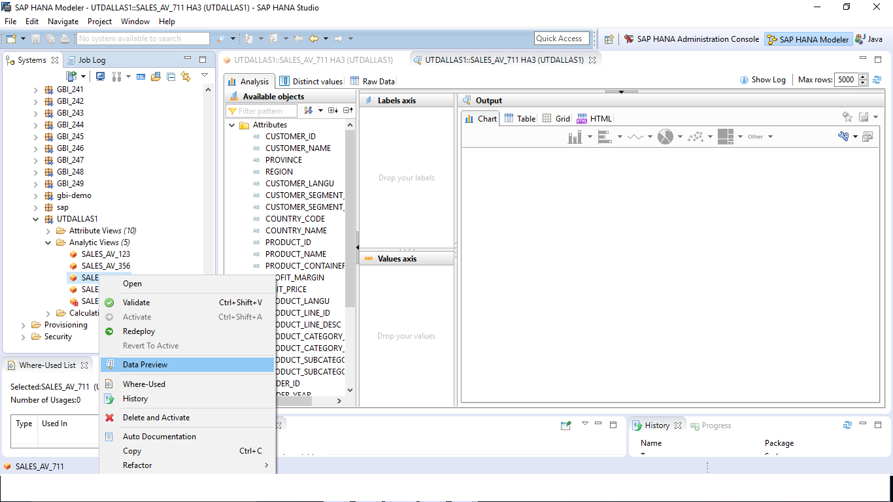

1. Select the Analysis Tab. Drag & drop CUSTOMER__NAME in Label axis and NET_SALES_REVENUE in Values axis.

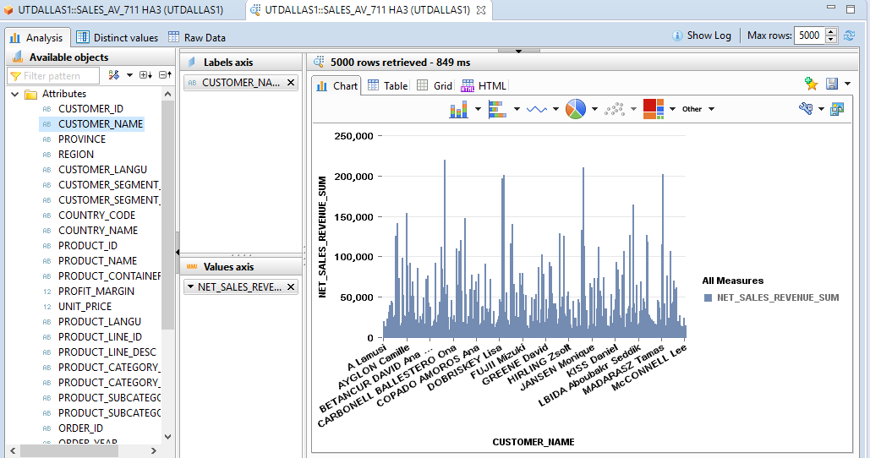

1. Right click on COUNTRY_NAME and click on *Add to filters*.

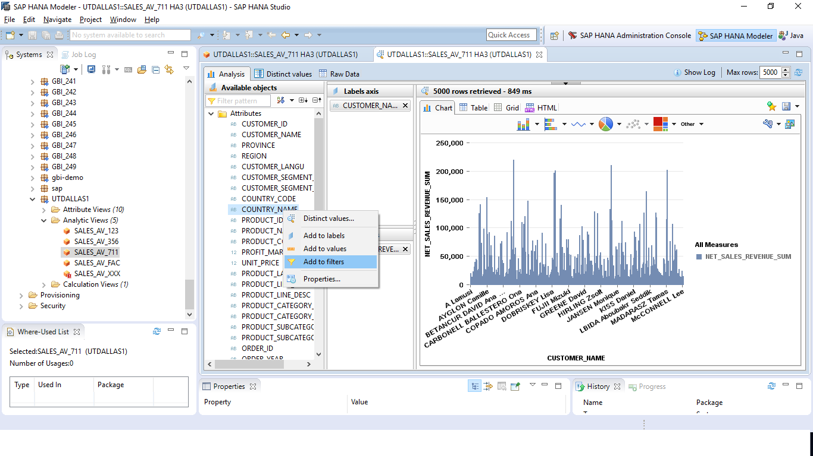

1. Similarly, right click on YEAR and click on *Add to filters*.
2. Now, select COUNTRY_NAME as ‘*Costa Rica’ and YEAR as ‘2025’* by clicking on it. As you click on them the graph will change automatically.

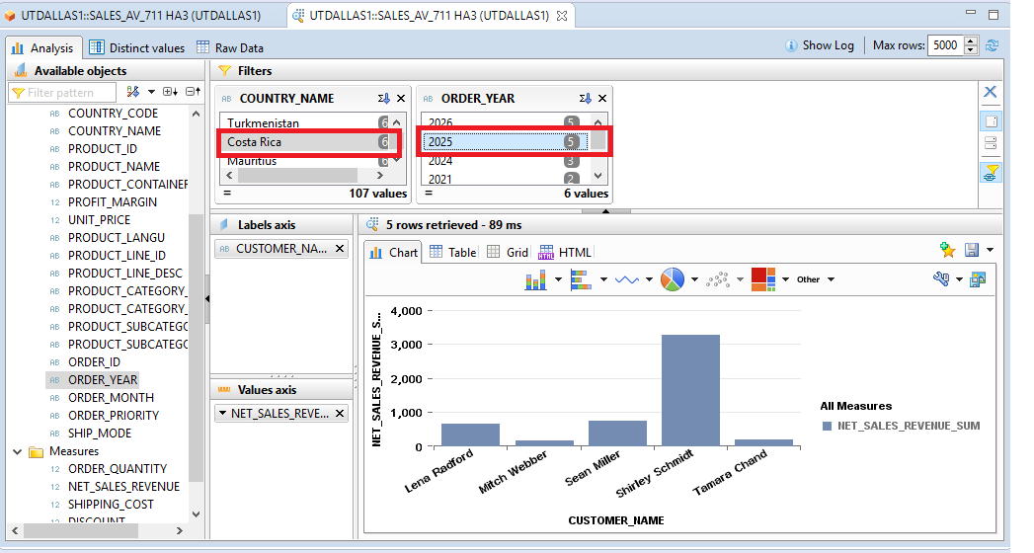

1. Click on the downward arrow next to NET_SALES_REVENUE and click on

*Sort ascending.*

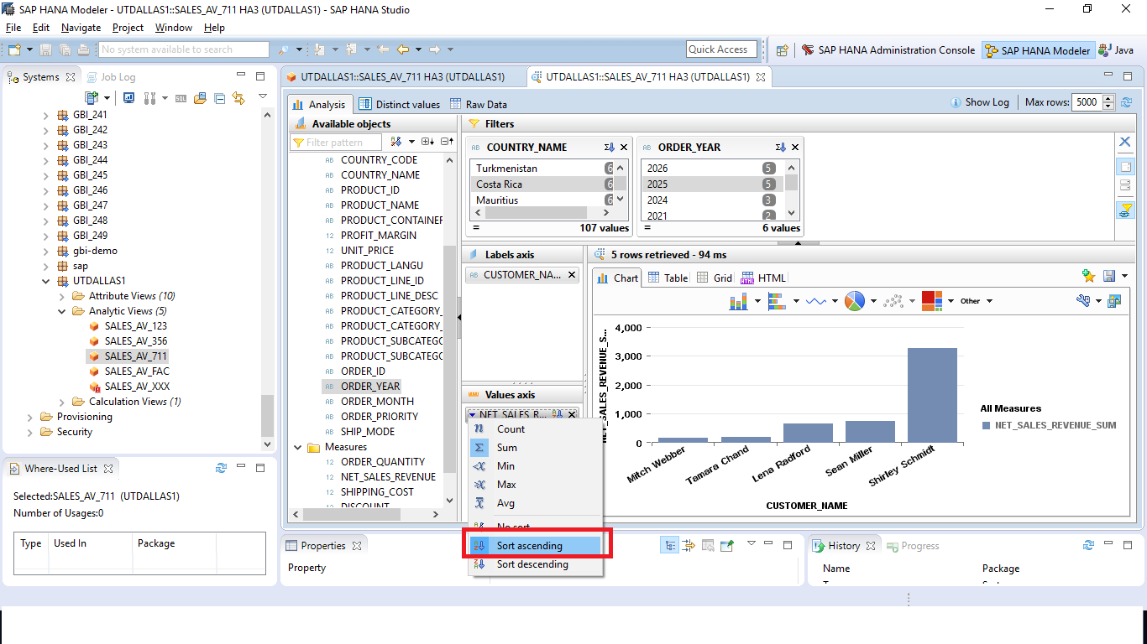

1. Paste the screenshot:

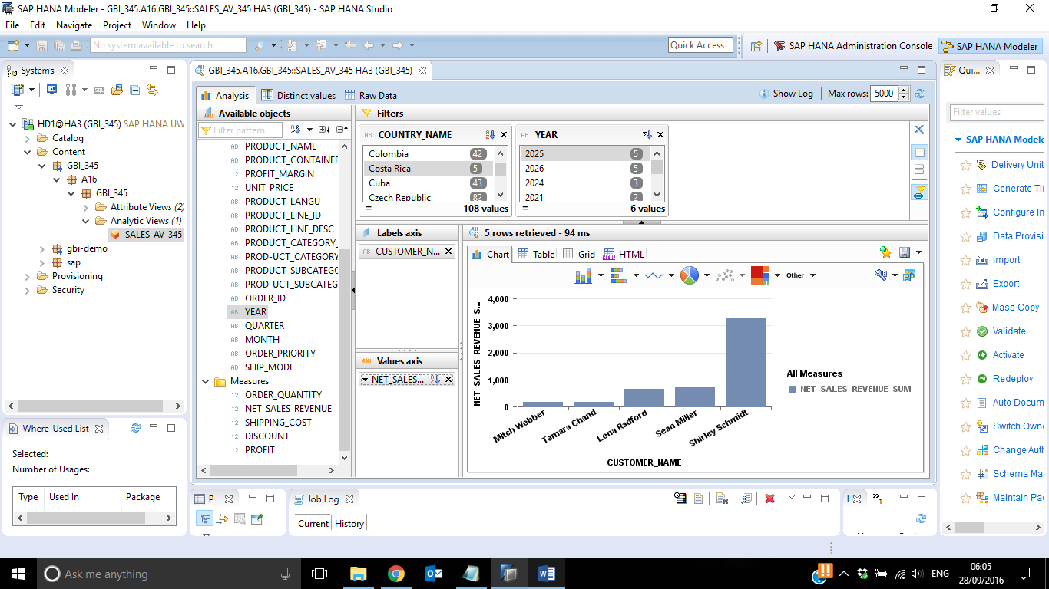

1. Remove CUSTOMER_NAME from Label axis. Drag & drop CUSTOMER_SEGMENT_NAME in Label axis. Select COUNTRY_NAME as ‘*India’ and YEAR as ‘2023’* by clicking on it. 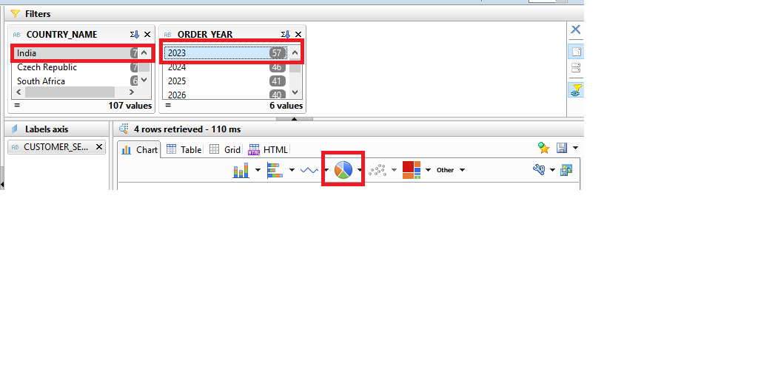
2. Select a Pie chart.

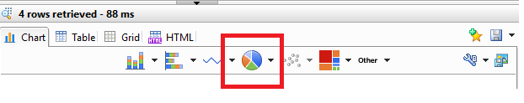

1. Paste the screenshot:

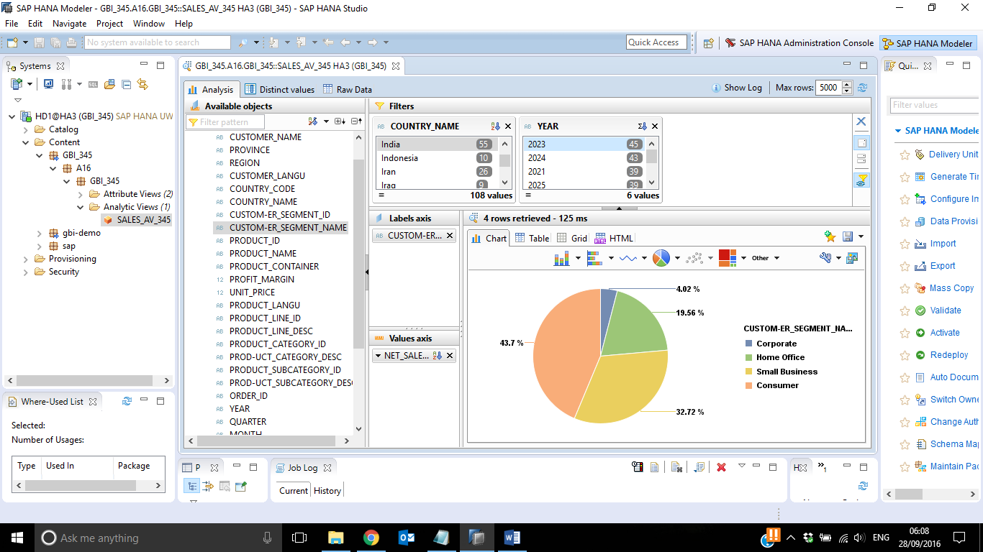

1. Remove all the filters. Also, remove all the attributes and measures from Label axis and Values axis. Drag & drop YEAR in Label axis. Drag & drop NET_SALES_REVENUE AND PROFIT in Values axis. Select a line chart.

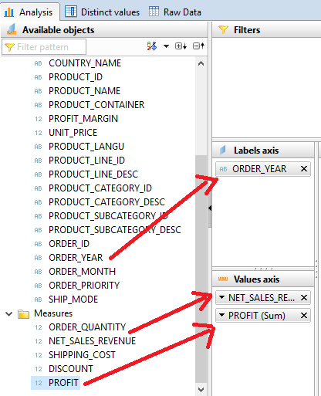

1. Add COUNTRY_NAME to filters and select *‘United States’*.
2. Paste the screenshot.

